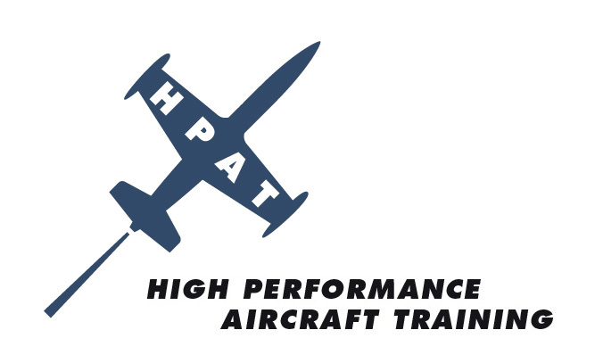

EVENT: ANNUAL SEBRING GROUND SCHOOL & RECURRENT FLIGHT TRAINING

DATE: Friday, February 20-Sunday, February 22, 2009

LOCATION: SEBRING REGIONAL AIRPORT
WWW.SEBRING.AIRPORT.COM
128 Authority Lane
Sebring, FL 33870
(863) 655.6444

COST: $395 Ground School ONLY
$795 Special Group Price for Ground School and Recurrent Flight Training

RSVP TODAY RSVP NOW - Limited Class Size
Visit www.hp-at.com website and click on events/Sebring 2009/Register

HOTEL: Chateau Elan/Four Points by Sheraton
and European Style Spa
www.starwoodhotels.com/fourpoints
150 Midway Drive
Sebring, FL 33870
(863) 655.6252
NOTE: Tell Reservations you are with High Performance Aircraft Group
Group Rates Available Thurs 2.19.09 through Sun 2.22.09
$110 Special Group Rate for Traditional Doubles
$125 Special Group Rate for Balcony/Kings
Check-in: 3:00pm/Check-out: NOON

For More Information Contact Glenda McKinney at Glenda@hp-at.com or (727) 524.9300

FLY SAFE WITH HIGH PERFORMANCE AIRCRAFT TRAINING

