FOR SALE $90,000 - 1995 LANCAIR 360

General Data:

Owner – Scotty & Karen Crandlemire PH# (208)-371-7530
Registration N-8190R
($100,000.00 invested)
Lycoming O-360 345 TTAFE
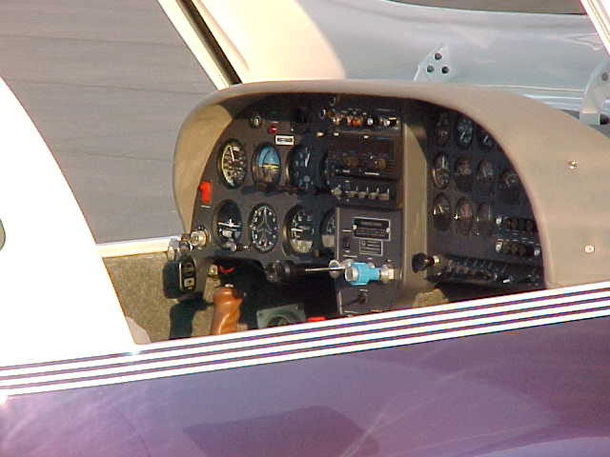
Exterior Paint – Chrome Illusion
Interior – Gray Leather

Basic Flight Instruments:

Airspeed Indicator, Vertical Speed Indicator
Altimeter, Artificial Horizon, Elec. Turn & Bank,
Glide Slope Indicator, Marker Beacon Light, G-Meter,
Vertical Compass, Wet Compass, Intercom by Drake
Communications, Mark 12e Narco Com/Nav (Vor & ILS)

Narco Transponder Mode/C

Engine Monitoring Instruments:

RPM Gauge, Manifold Pressure, Oil Pressure, Oil Temp,
Fuel Pressure, Cylender Temp, Exaust Gas Temp, Fuel Quanity,
Out Side Air Temp, Standard Circuit Breaker Panel.
