Leading Edge Composites
www.carbinge.com

COWLING INSTALLATION WITH CARBINGE

First here are some basic tricks and tips to help you get a vision of how to stay out of trouble and to get the best Carbinge attachment that you can.

- Mating surfaces in composite aircraft usually contain a “joggle” where an offset tab in the receiving portion allows an outside flush fit of the aircraft part that slips over the joggle. See figure 1.
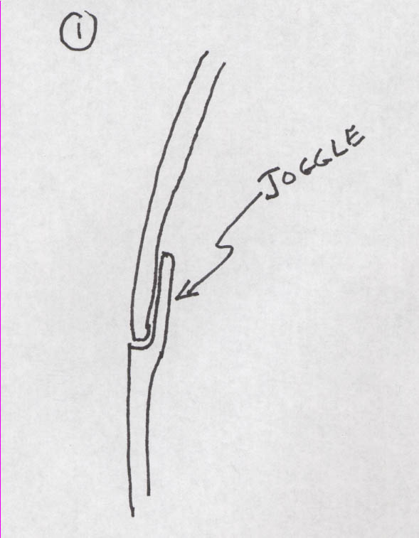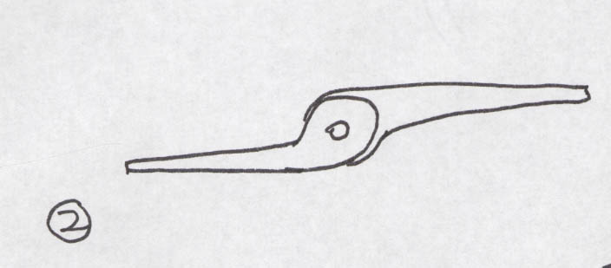

- Therefore it is often useful to reverse the orientation of the two Carbinge halves to better accommodate the offset created by the joggle. See figure 2. You need to evaluate this and experiment to see which orientation is best.
- Trial fitting prior to Carbinge attachment should be done with cleco clamps. Remember that these should be inserted initially where they will be able to secure the Carbinge to the part in subsequent steps so position them accordingly. Figure 3.
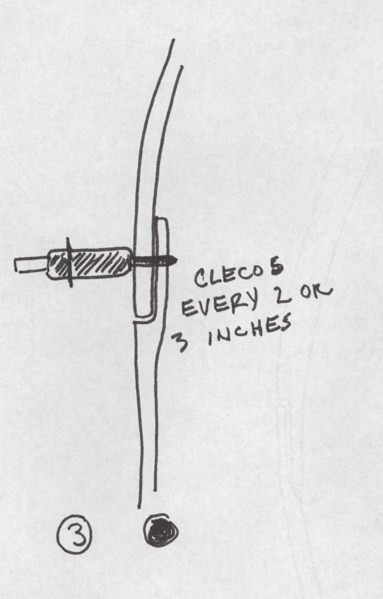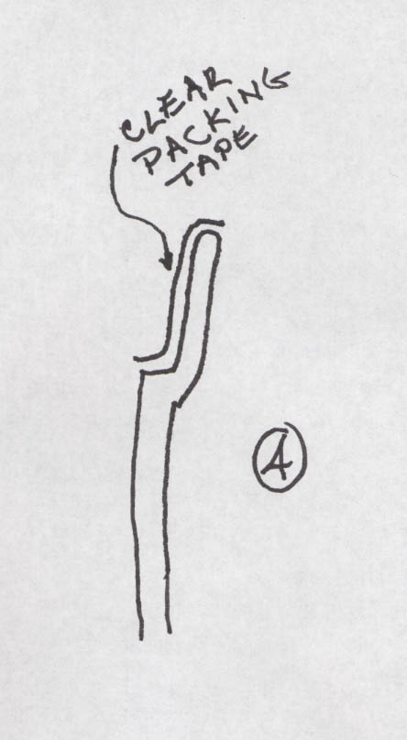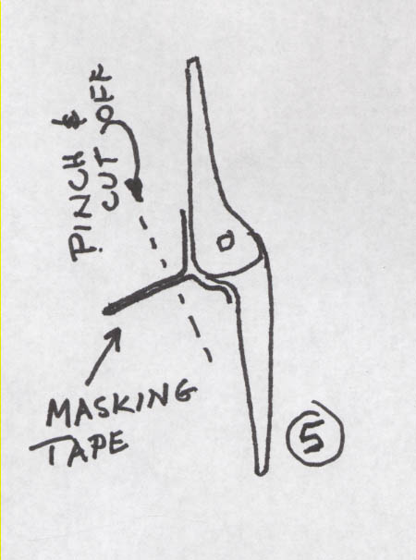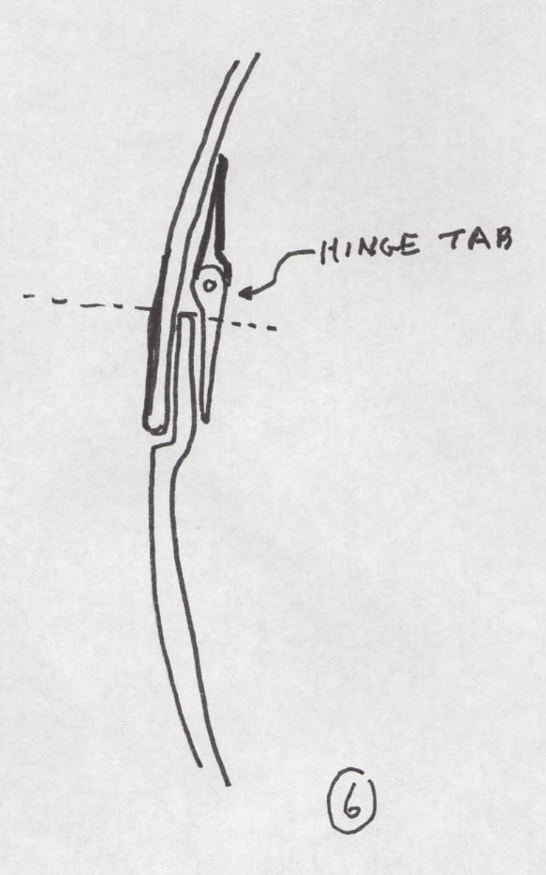
- Release tape can be used to keep the adhesive materials from going where you don’t want them. First, add clear packing tape on the joggle as shown in figure 4 to prevent an unwanted bond between the two aircraft parts. Masking tape works well to keep adhesive out of the hinge mechanism itself. Figure 5. This won’t work if you have to assemble the hinge halves after bonding, but you can still place masking tape or packing tape over the hinge tabs during adhesive application and clecoing, then removing prior to fitting the cowl back together. These release tapes can be placed at any step prior to applying adhesive, but don’t forget to place them and remember to remove them when your project is done. If you’ve placed them early in the process, be sure to recheck them for integrity prior to bonding.

The first step in cowl attachment is to trim and adjust the cowl to fit in all dimensions with the engine in place. You should cleco the joints in all planes so that the parts can be removed and replaced with no variations in position. Use plenty of Clecos to accomplish this.

Once this is accomplished you are ready to begin adding the vertical Carbinge pieces on the joint between lower cowl and fuselage tabs forward of the firewall. Measure and cut two lengths of Carbinge one for each side of the cowl. They will be less than 24” long so both can come out of one piece of Carbinge. Do not make these so long that they will have to negotiate the tight radius that begins to develop at the bottom of the cowl half. See photos. Place a 90 degree bent wire handle about ½ to 1” long at one end of each rear vertical pin. You won’t need Carbinge Keepers in this spot. Disassemble the Carbinge and clamp one half of it to the inside surface of the fuselage flange extending forward of the firewall. Use any sort of spring clamps that will securely hold the Carbinge in place. Align the Carbinge so that the hinge tabs will be forward of the leading edge of the flange. Figure 6. Now drill through the cleco holes you have already made in the flange so that they are through the Carbinge as well. At this point it will be useful to draw a pencil or other lofting line on the outside of the cowling where holes will be drilled to attach the remaining Carbinge half to the cowling itself. Do this by first using clecos to attach the reassembled Carbinge just to the fuselage. Measure from data points on the fuselage forward to several points along the Carbinge where you’ll want to drill your cleco holes. Transfer these measurements to the outside of the cowl and then scribe a line to intersect these points on the cowl. Figure 7.

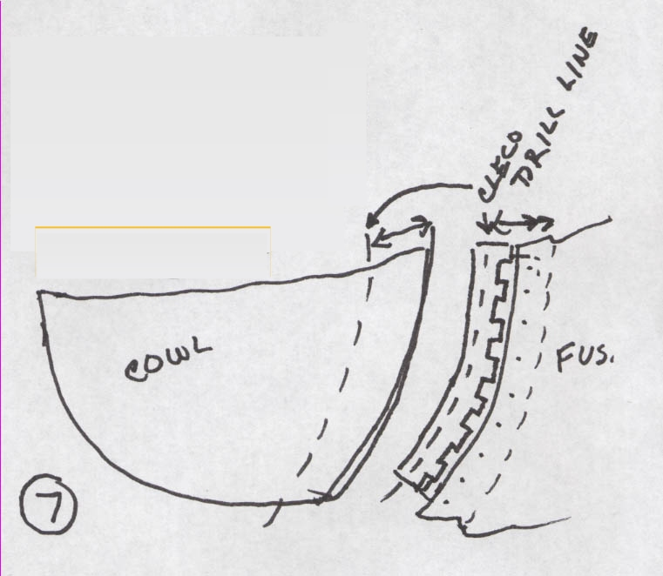

Reassemble the Carbinge and reassemble the entire cowling with the clecos, making sure that the fit is just as you want it. Include the reassembled Carbinge in this step. The 90 degree handle on the pin should be at the top. You may need to spot superglue the Carbinge in place on the fuselage to do the reassembly. Once everything is back in place, simply drill through the cowl AND the Carbinge along the loft line you have created. The Carbinge assembly will be stiff enough that with a sharp drill bit, you can accomplish this accurately. Place clecos in these holes and remove the upper cowl. Now pull the Carbinge pins on either side. Remove the cowl and examine the results of having attached the vertical Carbinge. If all looks OK, reassemble the cowl again, using the pins in the cleco’d Carbinge to attach lower cowl at the rear.

If everything still fits you are ready to bond the Carbinge to place. Do so, using best techniques for prep and cleanliness. Remove the top cowl and bond the rear vertical Carbinge peices in place and remove excess then add clecos. Remove clecos on one side at a time. Apply adhesive to the Carbinge and cleco THE Carbinge back to place. Apply peel ply over the margins to smooth out the junctions at the edge of the Carbinge. See photos. Do the same process on the opposite side. Prior to set, reassemble the entire cowl to make sure all is still aligned. Leave it like this until a good initial set is achieved. Remove the cowl and once you have complete cure and a fit you are satisfied with, add a two bid graphite layer over the bonded junction of the Carbinge and the aircraft part. This will sandwich the Carbinge to the part and will greatly reduce any risk of the Carbinge debonding from the aircraft at any time in the future. You can also add a Rivet or nut/bolt and each end of the Carbinge piece for additional resistance to debonding, but this is probably overkill.

Now you can begin the process on the horizontal Carbinge using similar steps as above. Use standard pins for now as the Carbinge Keepers will be added after the assembly is complete. In this case you cannot install the Carbinge with the cowl assembled, so I recommend removing the cowl from the fuselage and assembling the halves on a bench. Use the trial fitted Carbinge and its pin to align the hole that you will now make in the cowl for the exit of the pin. Drill about a 3/8” hole here. See photos again for positioning this hole. Bond both cowl sides, one at a time using the hole at the back of the cowl for access. Make sure the pins extend out the front of the cowl at this stage. When both halves are cleco’d to place with adhesive applied, take the cowl apart and attach to the fuselage. Reassemble the cowl completely and wait for initial set. You can then remove the cowl and wait for final set before adding the 2 BID sandwich layers. Do not try to extend the Carbinge far forward into the tight radius area near the air intake ports. See photos. Drill a slightly oversized hole for the Carbinge Keeper where it will emerge from the cowl and use some tubing to guide the pin for an inch or two after it goes through the Keeper button to the forward part of the Carbinge itself.

After horizontal attachments are done you can install the transverse piece across the back of the top cowl. See photos and website graphics to determine appropriate extent for this piece. The difference here is that you will not have access to the space when you bond the Carbinge to place. You can apply your bonding materials with the hinge apart then assemble the cowl using the pin to verify correct fit. Alternatively you can bond the assembled Carbinge to the fuselage, apply adhesive to the other half and install the cowl and then place the clecos to index the back of the top cowl to the Carbinge. I prefer the first method because you will be able to remove excess and to place peel ply before closing up the cowl.

Advice about pin insertion. If you’ve done a good job of alignment and have not got debris in the hinges, you should be able to insert and remove all pins without a great deal of trouble.

Please DO NOT use an electric drill to drive the pin in or out. You will be extremely likely to burn up the hinge bearing if you do. Instead have a helper bang on the outside of the cowl with an open palm along the junction of the cowl parts while you push or pull the pin. Be sure to grasp the pin close to the cowl itself to avoid kinking the wire.

If you have pins that will not seat without undue force, then try them in to the cowl parts unassembled. You will be able to discover if there is debris in the Carbinge this way. If so, try to clean out the parts of the hinge that are being obstructed. If not, then there is probably some slight misalignment of the Carbinge. Contact me for replacement pins with smaller diameter wire if this is the case.

