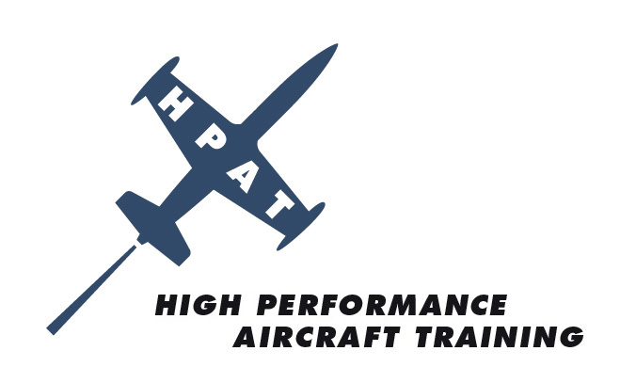

ANNUAL SEBRING GROUND SCHOOL & RECURRENT FLIGHT TRAINING
AGENDA

Thurs, February 19 Scheduled Flight Date/Time

Fri, February 20 Scheduled Flight Date/Time
1200-1800 Hrs – Meet and Greet at Sebring Regional Airport

Free Evening

Sat, February 21 JR’s Runway Café Open at 0700 Hrs
HPAT Registration Open at 0830 Hrs
Ground School; 0900-1200; Airport Conference Room
Lunch Break
Ground School; 1300-1700 Hrs
Networking; 1700 Hrs at JR’s Runway Café
Group Dinner – Details to be Announced

Sun, February 22 JR’s Runway Café Opens at 0700 Hrs
EFIS Class; 0900-1200 Hrs; Airport Conference Room
Scheduled Flight Training

Mon, February 23 Scheduled Flight Training, if needed

For More Information Contact Glenda McKinney at Glenda@hp-at.com or (727) 524.9300

FLY SAFE WITH HIGH PERFORMANCE AIRCRAFT TRAINING

