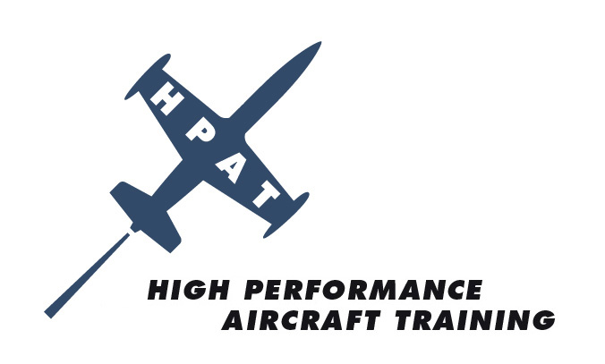

**EVENT: ANNUAL SEBRING GROUND SCHOOL & RECURRENT FLIGHT TRAINING**

**DATE: Friday, February 20-Sunday, February 22, 2009**

**LOCATION: SEBRING REGIONAL AIRPORT**

[WWW.SEBRING.AIRPORT.COM](http://WWW.SEBRING.AIRPORT.COM)

128 Authority Lane

Sebring, FL 33870

(863) 655.6444

**COST:** $395 Ground School ONLY

$795 Special Group Price for Ground School and Recurrent Flight Training

**RSVP TODAY** **RSVP NOW** - Limited Class Size

Visit [www.hp-at.com](http://www.hp-at.com) website and click on events/Sebring 2009/Register

**HOTEL:**  Chateau Elan/Four Points by Sheraton

and European Style Spa

[www.starwoodhotels.com/fourpoints](http://www.starwoodhotels.com/fourpoints)

150 Midway Drive

Sebring, FL 33870

(863) 655.6252

NOTE: Tell Reservations you are with High Performance Aircraft Group

Group Rates Available Thurs 2.19.09 through Sun 2.22.09

$110 Special Group Rate for Traditional Doubles

$125 Special Group Rate for Balcony/Kings

Check-in: 3:00pm/Check-out: NOON

For More Information Contact Glenda McKinney at [Glenda@hp-at.com](mailto:Glenda@hp-at.com) or (727) 524.9300

***FLY SAFE* WITH HIGH PERFORMANCE AIRCRAFT TRAINING**