LANCAIR IVP – FOR SALE
$325,000 – Located in Southern California
Contact Pat Brunner, N98PB@sbcglobal.net

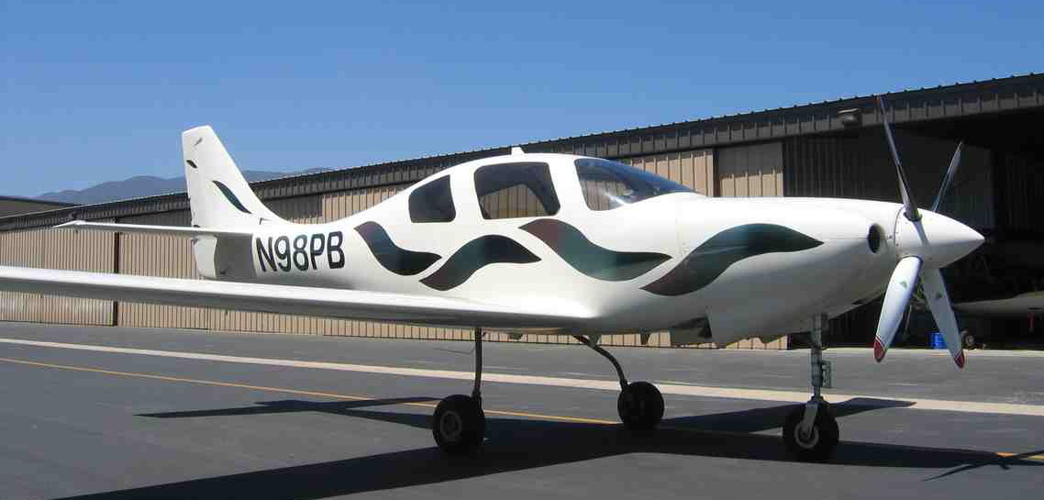

Aircraft Summary:
Year: 1999
Airframe TTime: 780 Hours
Engine Time: 780 Hours
Engine: TSIO 550E2B
Aircraft always hangared – leather interior

Avionics and Equipment:
~VM1000 engine analyzer
~VM fuel gauges

~V100 Annunciator panel
~Dual Chelton sport system w/ pinpoint
GADAHRS
~Proprietary Pro AOA
~CDI w/GS
~Dukes pressure controller
~PSI 6000 audio panel w/ marker beacon
~Garmin SL30 nav/com tied to Chelton
~King KX 165 tied to CDI
~King DME

~King KT76 transponder and blind encoder
~TruTrak DigiFlight II auto pilot VGVS
~Garmin 396 mounted in glove box w/ weather
~Ryan 9900B TCAS tied to Chelton
~4 noise canceling David Clark panel-mounted headsets
~Dynon D10A EFIS w/ battery backup
~Speed brakes
~Dual alternators
~4 bladed MT propeller
~Bruce’s Custom Cover

